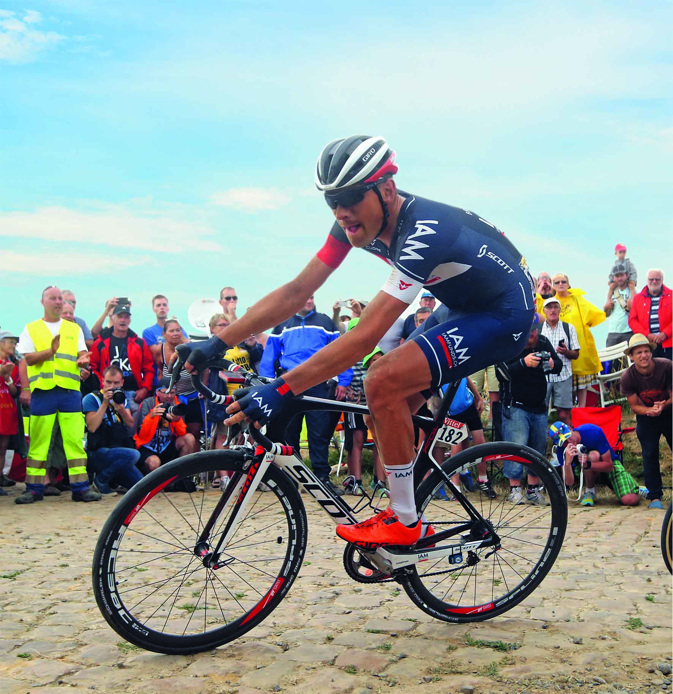

Tubeless in the Tour de France: professionals like the Swiss Martin Elmiger (IAM Cycling Team) already put the Schwalbe Pro One through extreme conditions. Photo: Schwalbe / Graham Watson

Pro One: Schwalbe’s new top tire

counts on tubeless

Schwalbe takes tubeless technology to the next level: The technicians have now succeeded in making the tubeless construction even lighter and faster. The new Pro One racing tire thus weighs an impressive 70 grams less than its predecessor. This evolutionary step will establish tubeless technology once and for all – even for professional racing bikes.

Once you go tubeless, you never go back. The technology is also gaining acceptance among more traditional professionals. Tubeless Easy tires were used at the most important UCI WorldTour races in 2015 – whether Tour de France, Giro d’Italia, Tour Down Under or Paris-Roubaix.

“Our next evolutionary step makes the entire system even lighter, faster and more user-friendly. The time for a system change has come!” Peter Krischio, Product Manager Race at Schwalbe, is convinced. Other component manufacturers are also following this trend. Krischio expects significantly more tubeless-ready rims and wheels in 2016.

MicroSkin: The new key technology for Tubeless Easy

The development of MicroSkin differentiates this year’s tubeless tires from last year’s. The patented construction consists of a high-tensile micro fabric which is vulcanized together with the rubber compound and the carcass. MicroSkin envelops the entire carcass and facilitates a fault-free Tubeless Easy operation, just like SnakeSkin on a MTB tire.

Tubeless Easy tires have long since made a name for themselves in the mountain biking community. “The MicroSkin construction allows us to implement the Tubeless Easy principle for high-pressure tires for the very first time. The fabric fulfills several important functions simultaneously: It ensures impermeability. It guarantees reliable high-pressure stability. And as an aside, it also improves the overall cut resistance,” Peter Krischio explains.

With a weight of 235 grams, this carefully balanced construction makes the new Pro One 25 percent lighter than the previous tubeless tires – that is an impressive 70 grams! And this also makes it even faster – by ten percent compared to its predecessor and as much as 25 percent compared to folding tires. Compared to tires with a similar puncture protection, such as the Durano, rolling resistance is improved by over 40 percent.

The Schwalbe Pro One is a Tubeless Easy tire. Using a little liquid sealant is necessary, yet a longwinded conversion process involving intense shaking and frequent re-inflation is not necessary. Compared to classic tubeless tires, it is far easier to assemble.

Schwalbe’s One Range of 2016: Four New Tubeless Easy Tires.

Schwalbe is launching many Tubeless Easy tires just in time for Eurobike – thus being the very first manufacturer to offer tubeless tires for practically every cycling discipline.

The new Schwalbe Pro One is the number one model for ambitious cyclists. As a second-generation tubeless tire with MicroSkin, it offers competition tire performance of the highest order. Of course it can also be ridden with an inner tube – its true strengths will, however, be the most evident during tubeless operation.

For spring classics, Schwalbe is launching the S-One. It is a specialist model for the toughest races such as the Tour of Flanders or the Paris-Roubaix. It is very well equipped for such arduous races with its high volume and additional V-guard belt. It can be ridden “old school” as a hand-made tubular tire or with state-of-the-art Tubeless Easy technology. Professionals such as Martin Elmiger or Sylvain Chavanel (both Team IAM) were amazed by the speed, comfort and reliability with which the tubeless tire carried them over the unforgiving terrain at the Paris-Roubaix – and which helped the Swiss Elmiger to finish fifth.

The Schwalbe X-One is for Cyclo-Cross racers. The new profile and the OneStar rubber compound already make it one of the fastest cross tires ever. However, it unleashes its true potential when used tubeless on a special tubeless-ready wheel. This enables tubeless tires to be used in Cyclo-Cross at extremely low air pressures without the risk of “burping” (undesired air loss).

The fourth new model of the One family, the Schwalbe G-One, was designed specially with an eye on the new “gravel bike” trend. It is a sheer pleasure to fly over field and forest tracks with a profile that facilitates easy rolling, as well as the Tubeless Easy technology. If frame design allows sufficient room, the 40 millimeter version is the best choice due to its high volume.

**The tires by far outperform previous folding and tubular tires**

“We aim to push tubeless technology a lot further with this product range. The tubeless system has the potential to come out on top in the professional road racing market and one day to replace tubular tires. The tires outperform previous folding and tubular tires by a long distance,” Peter Krischio says in conclusion. This applies to all types of bikes. The Marathon Supreme and Marathon Almotion models are now also equipped with MicroSkin for tubeless use. Schwalbe is therefore the first manufacturer to include tubeless tires in its product range for all bike types.

Tires in the new Pro One family will be available at specialized bicycle retailers in 2016 starting from 59.90 EUR.

This press release with photos and Graphics can be downloaded from: www.schwalbe.com/en/presse.html

SCHWALBE - Ralf Bohle GmbH ⬝ Doris Klytta

Otto-Hahn-Straße 1 ⬝ 51580 Reichshof-Wehnrath

Telefon: +49 2265 109-57 ⬝ Fax: +49 2265 7022

[d.klytta@schwalbe.com](mailto:d.klytta@schwalbe.com) ⬝ [www.schwalbe.com](http://www.schwalbe.com)

**Supplement:**

**General advantages of the Tubeless System:**

**Faster, safer, more control**

Racing bike, mountain bike or touring bike – tubeless offers the best performance for bikes. Tubeless is the right choice for all athletic ambitious cyclists when it comes to:

1. **Speed:** As there is no tube, there is no friction between tire and tube. This crucially reduces the rolling resistance. It is even lower than with super-light competition tires.
2. **Grip and comfort:** You can ride tubeless with a lower tire pressure without compromising performance. This brings noticeable advantages in comfort, but also significantly more control in critical situations and on poor routes.
3. **Puncture protection:** Tubeless systems have a very high puncture protection. Sudden air loss due to bursting tubes or valves tearing is ruled out. A puncture protection fluid re-seals punctures while riding within tenths of a second. The danger of snake bites is also much lower than with tube systems.

**The Schwalbe One-Range 2016:**

**Four new Tubeless Easy tires**

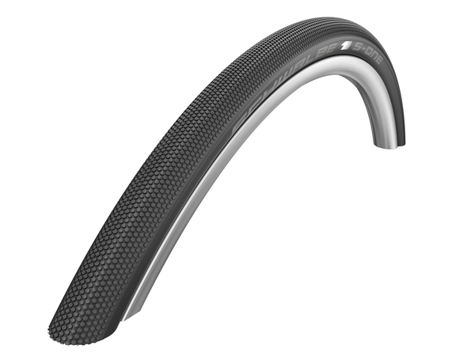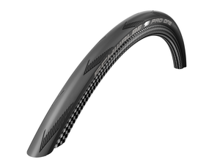

**Pro One: Top tire for ambitious cyclists - S-One: The special tire for spring classics - tubeless or as classic tubular tire. tubeless or as classic tubular tire.**

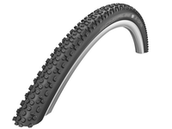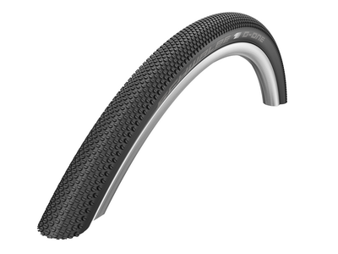

**X-One: New profile for cyclo-cross bikes. G-One: For Gravel-Bikes.**

**It rolls fastest in tubeless mode**. **Rolls tubeless on dirt and forest tracks**

**Rolling resistance**

**17 watts! The new Pro One rolls ten percent faster than its predecessor, the Schwalbe One, and as much as 25 percent faster than the folding tire. In practice, compared to tires with a similar puncture protection such as the Durano, the difference amounts to over 40 percent.**

